Week 4 assignment
Q1. Yellow Taxi Data Quality Check (2023)

WITH valid_data AS (
SELECT *
FROM yellow_2023
WHERE total_amount IS NOT NULL AND total_amount >= 0
AND trip_distance IS NOT NULL AND trip_distance >= 0
AND passenger_count IS NOT NULL AND passenger_count > 0
),
standardized_data AS (
SELECT
VendorID,
tpep_pickup_datetime,
tpep_dropoff_datetime,
passenger_count,
ROUND(trip_distance, 3) AS trip_distance,
ROUND(total_amount, 3) AS total_amount,
CASE
WHEN TRIM(UPPER(store_and_fwd_flag)) = 'Y' THEN 'Y'
WHEN TRIM(UPPER(store_and_fwd_flag)) = 'N' THEN 'N'
ELSE NULL
END AS store_and_fwd_flag
FROM valid_data
),
labeled_data AS (
SELECT
VendorID,
tpep_pickup_datetime,
tpep_dropoff_datetime,
passenger_count,
trip_distance,
total_amount,
store_and_fwd_flag,
CASE
WHEN passenger_count = 1 THEN 'Solo'
WHEN passenger_count BETWEEN 2 AND 3 THEN 'Small Group'
WHEN passenger_count BETWEEN 4 AND 6 THEN 'Medium Group'
WHEN passenger_count > 6 THEN 'Large Group'
ELSE 'Unknown'
END AS trip_size_label
FROM standardized_data
)
SELECT
VendorID,
tpep_pickup_datetime,
tpep_dropoff_datetime,
passenger_count,
trip_size_label,
trip_distance,
total_amount,
store_and_fwd_flag
FROM labeled_data
LIMIT 20;
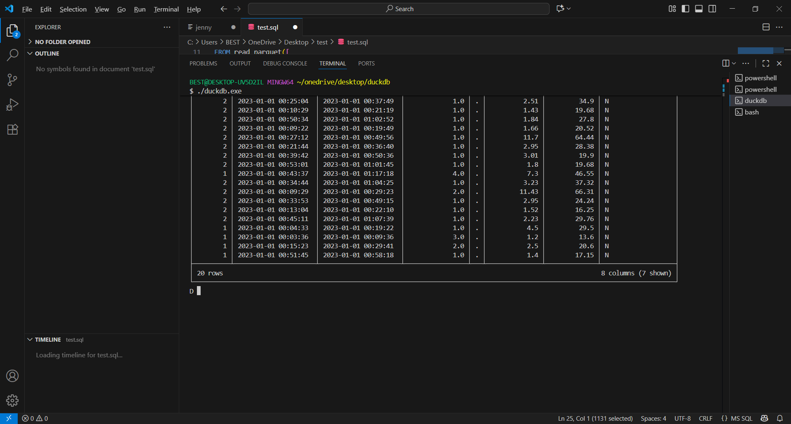
Q2. Monthly Revenue Analytics

Step B – Segment revenue by VendorID with percentages

WITH monthly_revenue AS (
SELECT
LPAD(strftime('%m', tpep_pickup_datetime), 3, '0') AS month_number,
strftime('%B', tpep_pickup_datetime) AS month_name,
SUM(total_amount) AS monthly_revenue
FROM cleaned_yellow_2023
WHERE strftime('%Y', tpep_pickup_datetime) = '2023'
GROUP BY month_number, month_name
)
SELECT
month_number,
month_name,
monthly_revenue,
LAG(monthly_revenue) OVER (ORDER BY month_number) AS previous_month_revenue
FROM monthly_revenue
ORDER BY month_number;
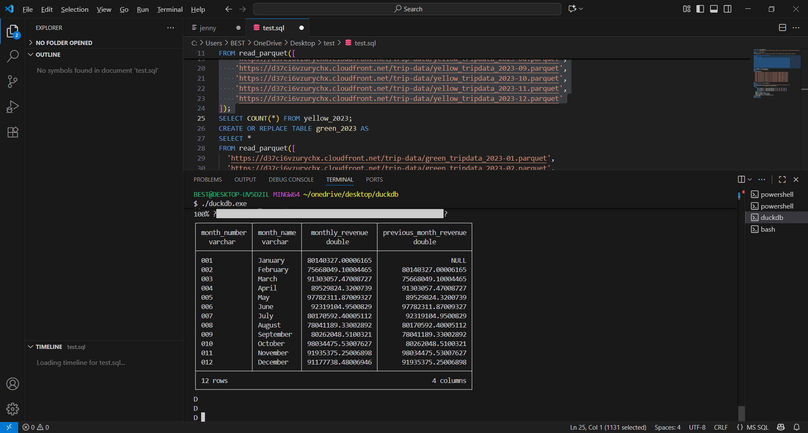

Step B. Segment revenue by VendorID with percentages
WITH monthly_vendor_revenue AS (
SELECT
LPAD(strftime('%m', tpep_pickup_datetime), 3, '0') AS month_number,
strftime('%B', tpep_pickup_datetime) AS month_name,
VendorID,
SUM(total_amount) AS vendor_monthly_revenue
FROM cleaned_yellow_2023
WHERE strftime('%Y', tpep_pickup_datetime) = '2023'
GROUP BY month_number, month_name, VendorID
),
total_monthly_revenue AS (
SELECT
month_number,
SUM(vendor_monthly_revenue) AS total_revenue
FROM monthly_vendor_revenue
GROUP BY month_number
)
SELECT
m.month_number,
m.month_name,
m.VendorID,
m.vendor_monthly_revenue, t.total_revenue,
ROUND(100.0 * m.vendor_monthly_revenue / t.total_revenue, 2) AS vendor_revenue_pct
FROM monthly_vendor_revenue m
JOIN total_monthly_revenue t
ON m.month_number = t.month_number
ORDER BY m.month_number, m.VendorID;
